Experiment 03 - Classification using Rapid Miner tool

| Roll No. |  |
| --- | --- |
| Name |  |
| Class | D15A |
| Subject | Business Intelligence Lab |
| LO Mapped | LO3:  Implement the appropriate data mining methods like classification, clustering or association mining on large data sets using open-source tools like WEKA |
| Grade |  |

**Implementation:**

**\*\* Initially we had 5110 entries/rows \*\***

**1. Splitting the dataset in training data**

Process - 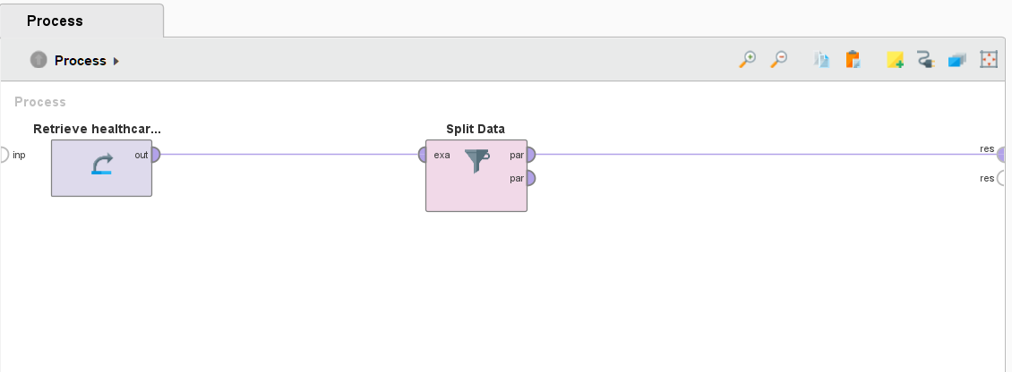

Dataset -

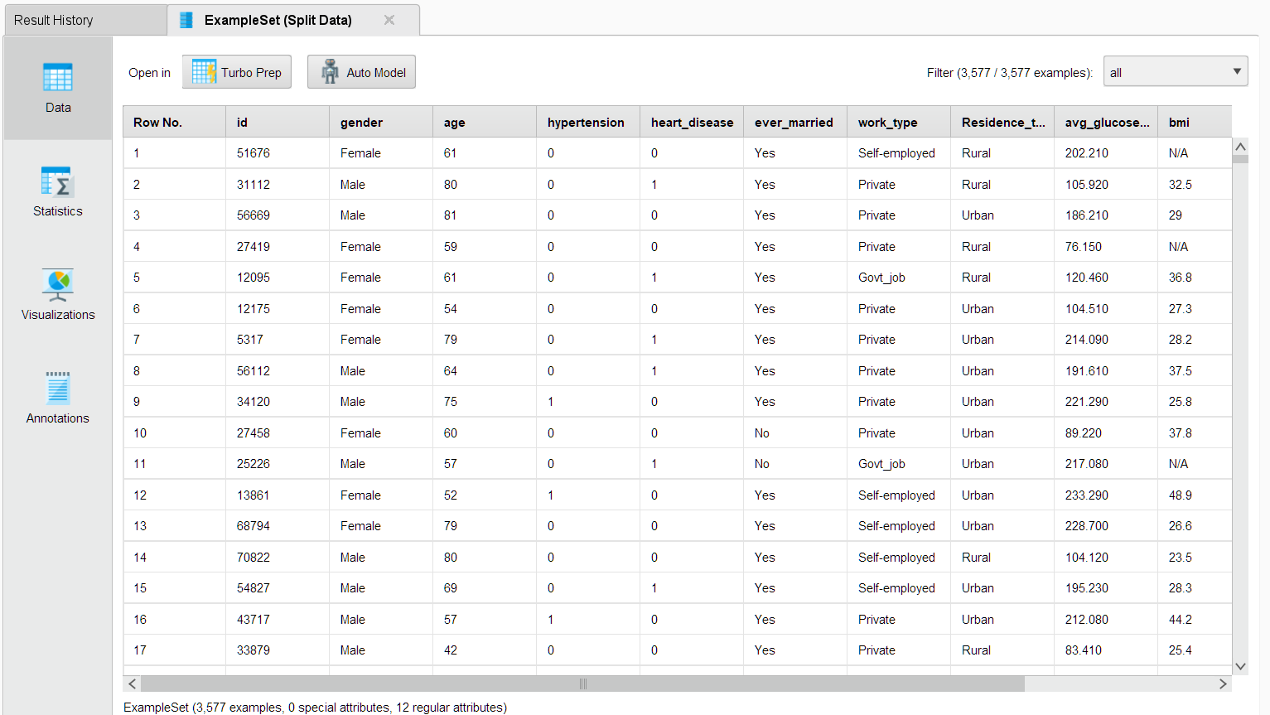

**2. Splitting the dataset in test data**

Process

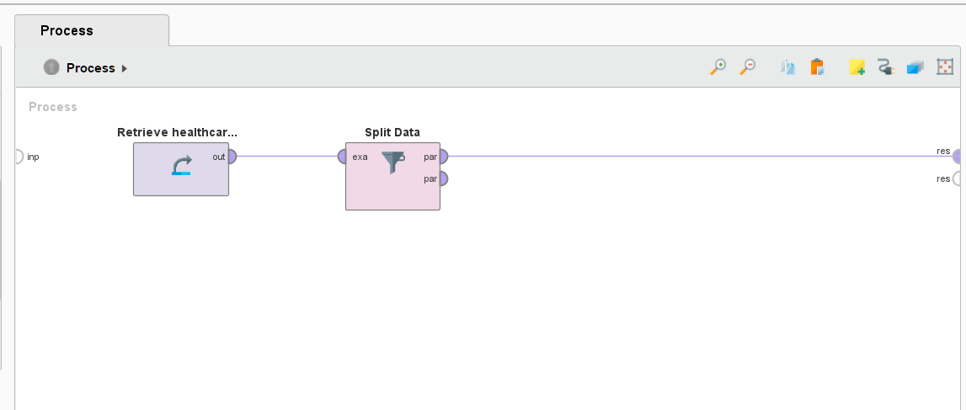

Dataset -

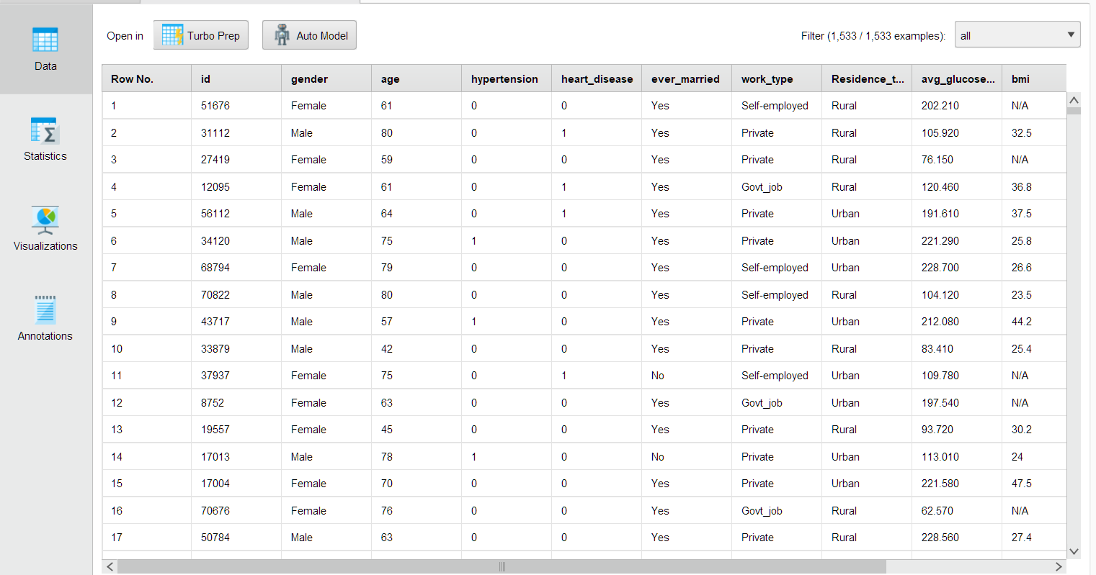

**3. Decision tree of training data**

Process -

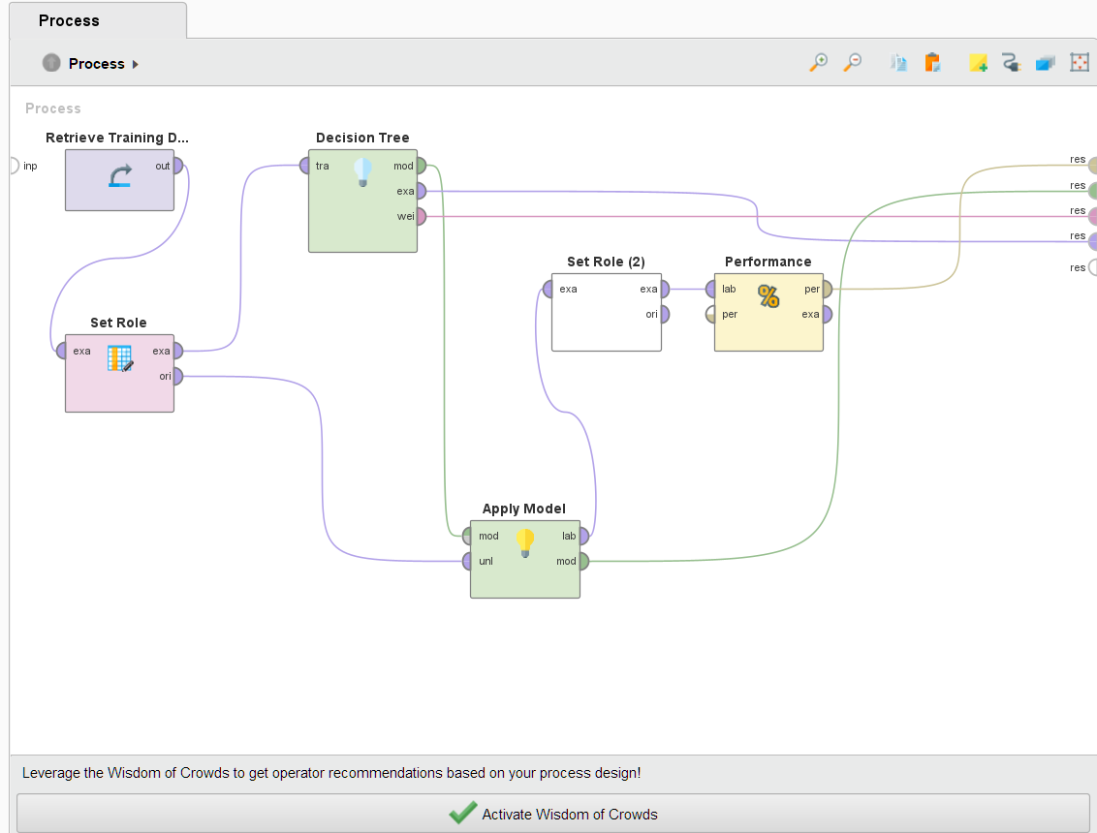

Tree -

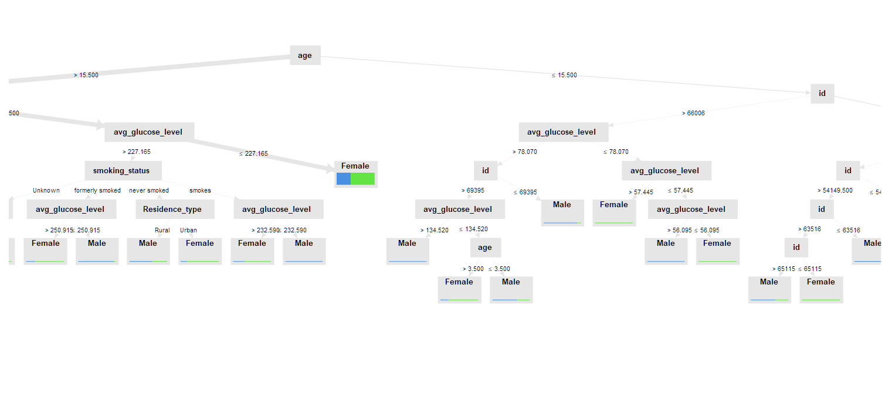

Performance matrix - 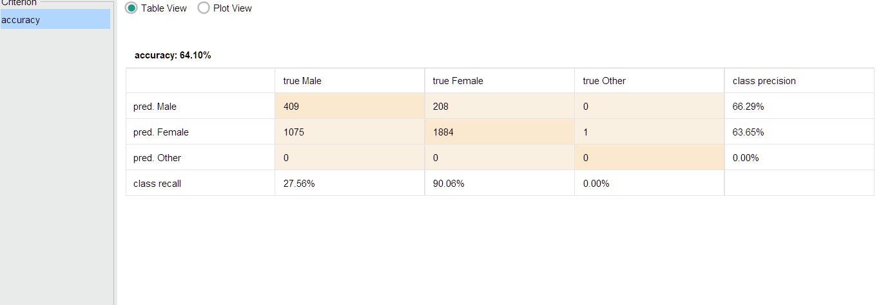

**4 . Decision tree of test data**

Process -

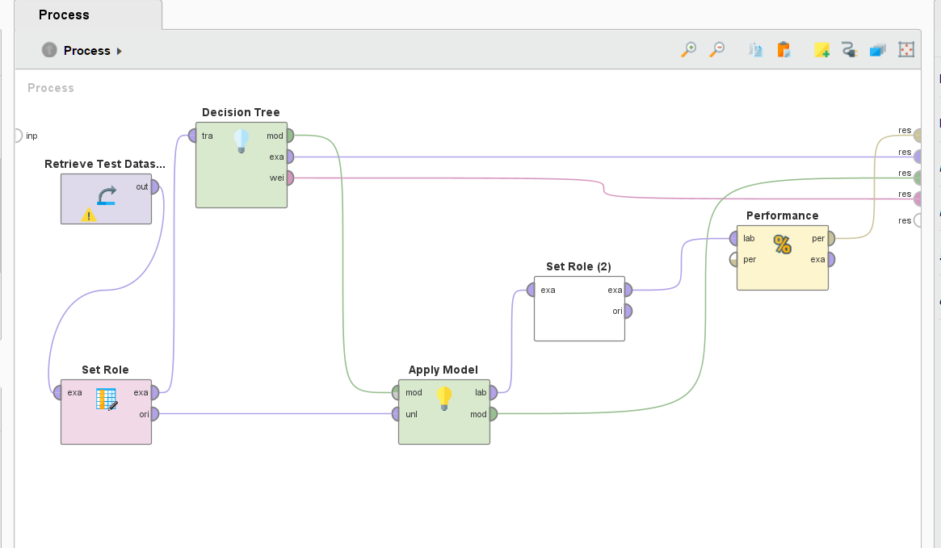

Tree -

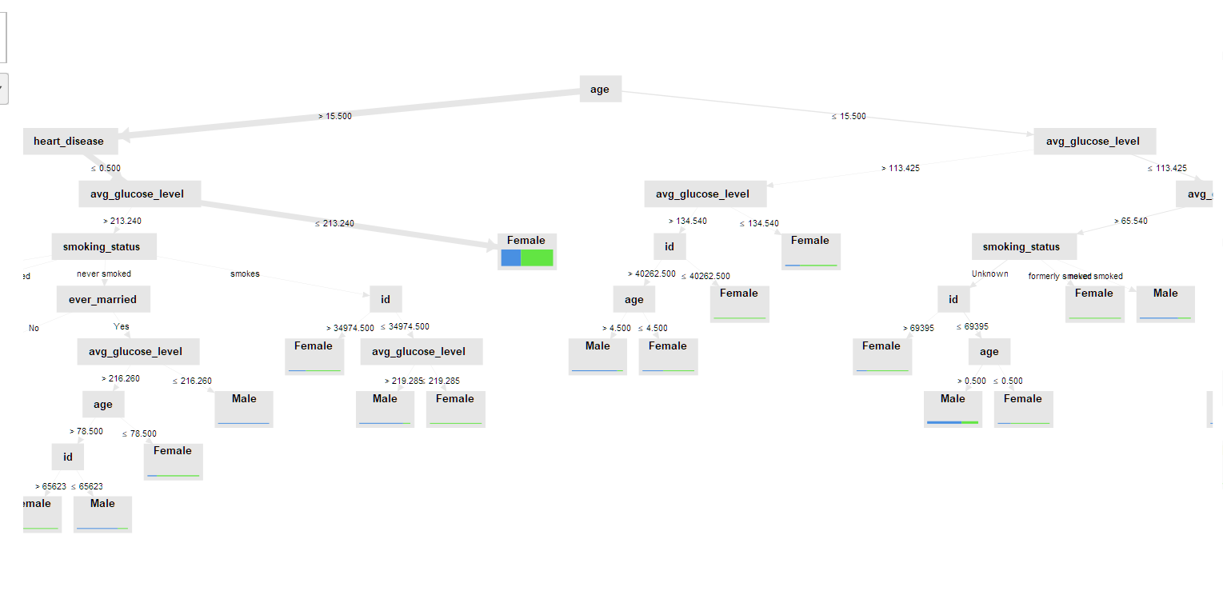

Performance matrix -

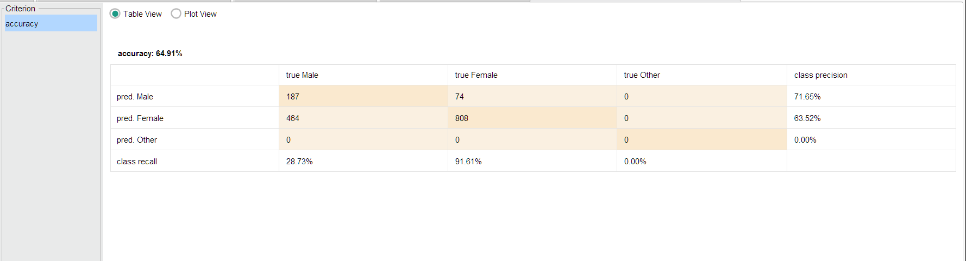

**5. Naive Bayes of training data**

Process -

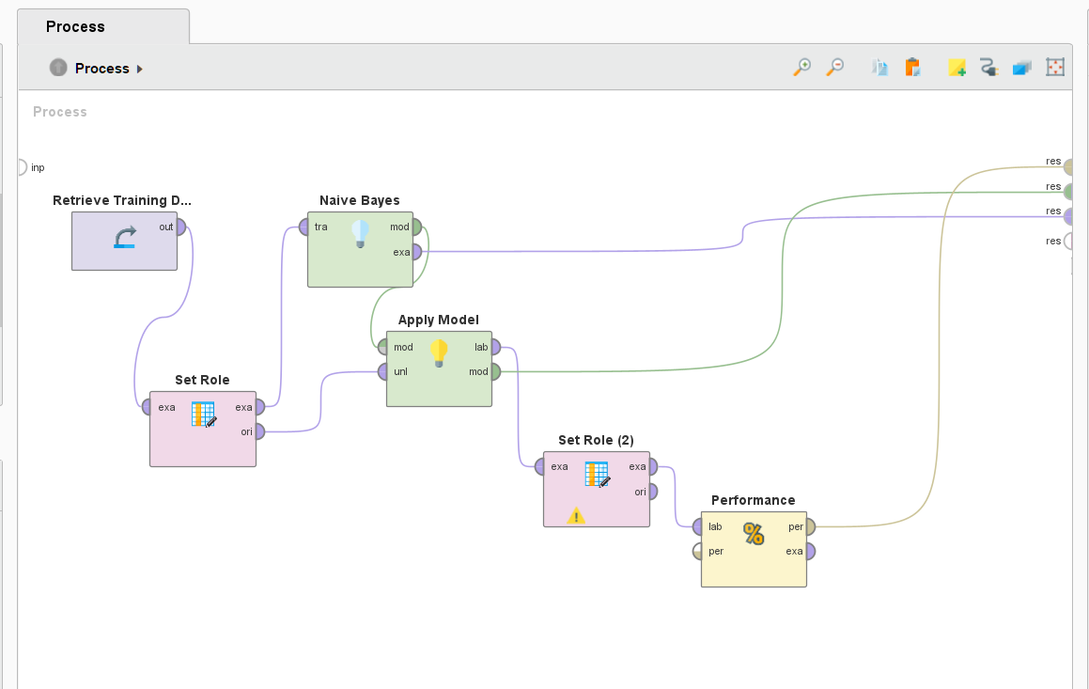

Simple Distribution -

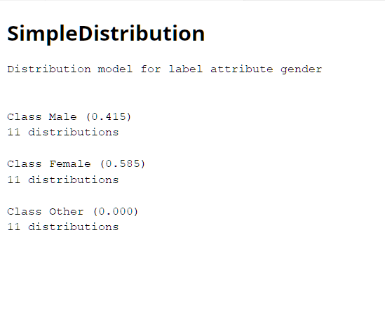

Performance matrix -

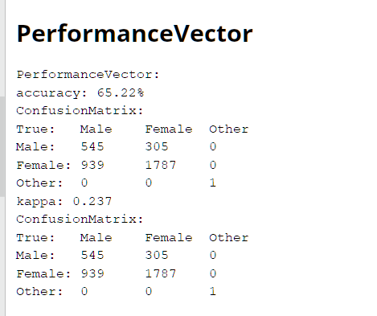

**6. Naive Bayes of test data**

Process -

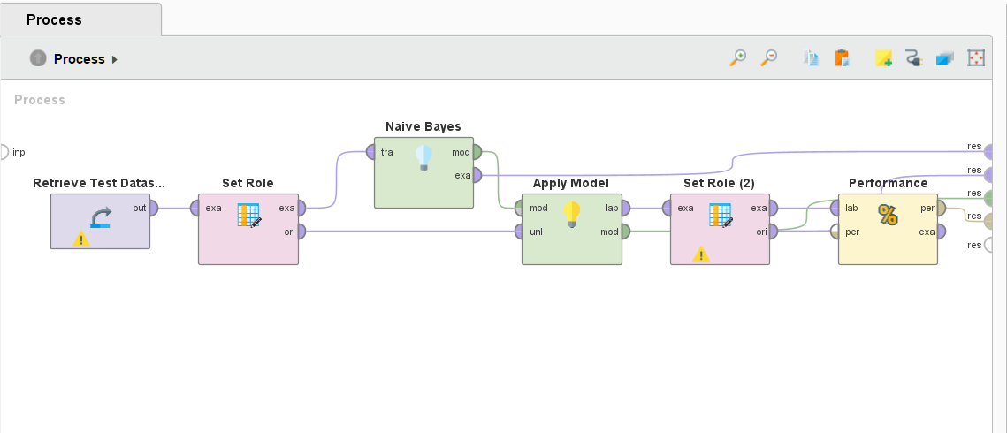

Simple Distribution -

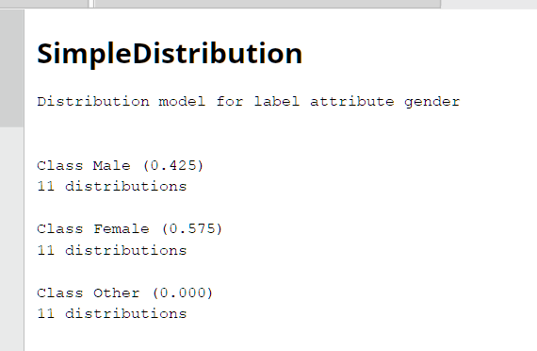

Performance matrix -

